Log data:
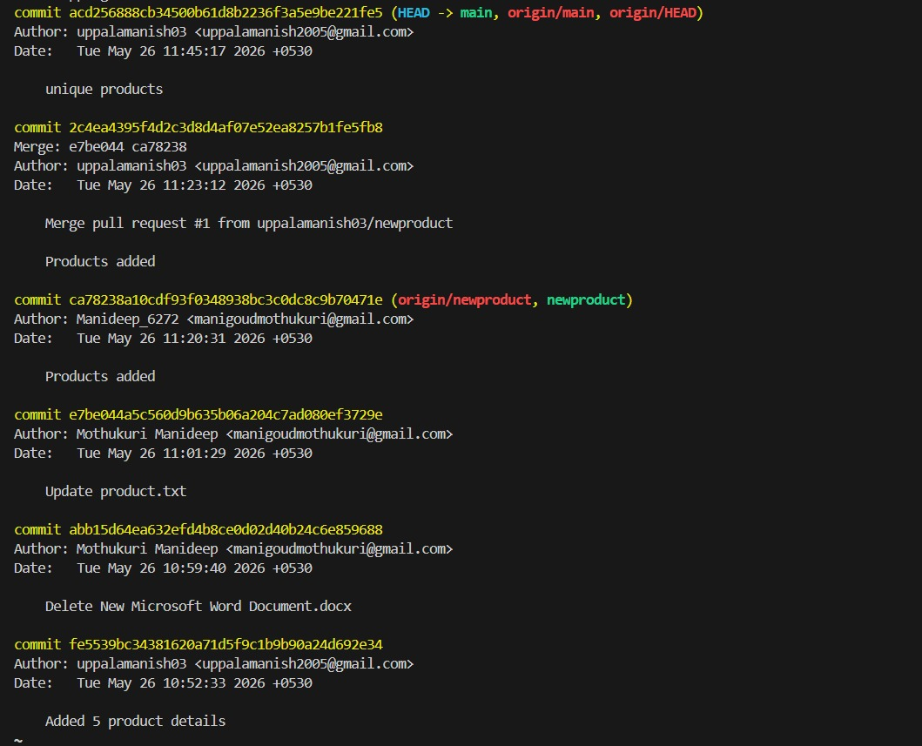
Git repo link: https://github.com/uppalamanish03/shopping_project
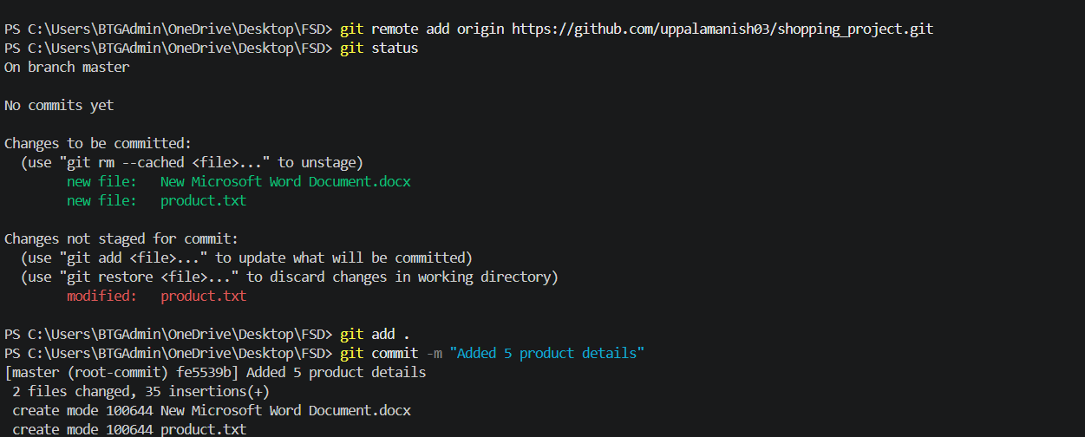
Step-1: Add initial product data
Step-2:Commit and push to main.
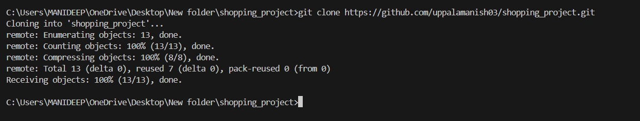
Step-3: clone repository (developer 2)
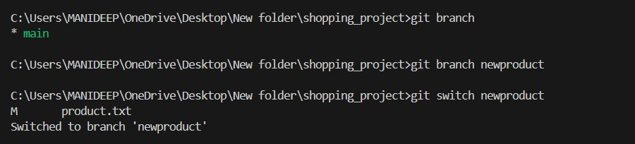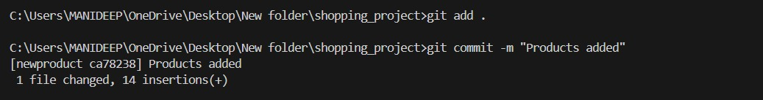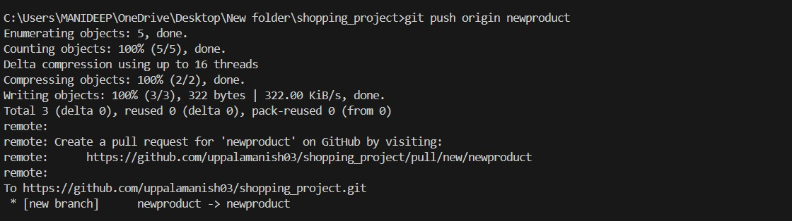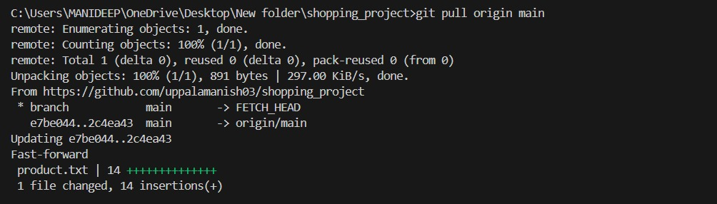
Step-4: Create branch add-products.
Step-5: Commit and push changes.

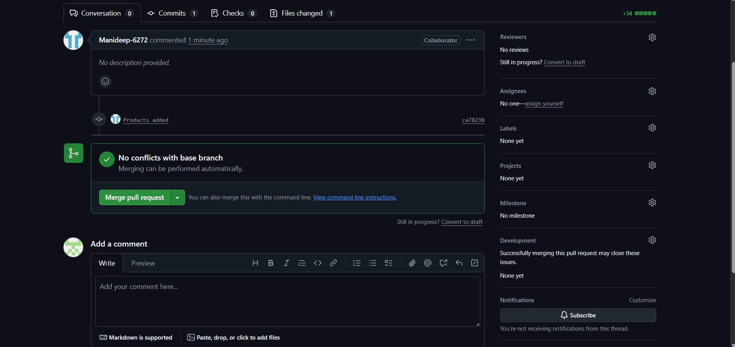
step-6:pull and merge request
